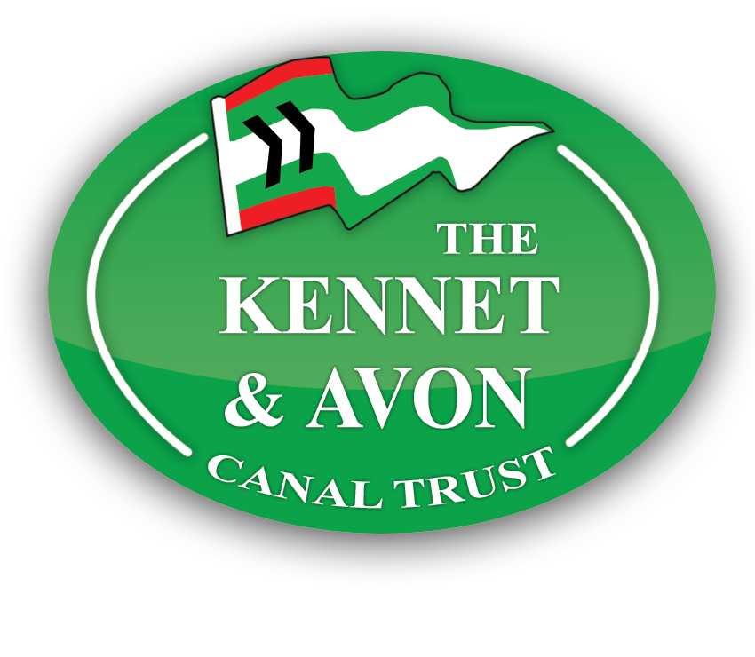**BARBARA McLELLAN:**

**Charter FAQs**

**NEW FOR 2025**

**YOU CAN NOW BOOK A CHARTER ON-LINE YOURSELF.**

***DATES AND OPTIONS ARE ON THE “BOOK A TRIP” PAGE ON OUR WEBSITE.***

**Where can we go and how much does it cost?:**

Routes & pricing:

Avoncliff Aqueduct – go down through the lock. 2.5 hours. £325

Hilperton – go east to the turning point at Hilperton. 2.5 hours. £325

Dundas – go west, over Avoncliff Aqueduct and on to Dundas Aqueduct in the Limpley Stoke Valley. 5.5 hours. £500

Meadows Bridge – go down through the lock to the first turning point. 1.5 hours. £275

Dundas: 10 am

Avoncliff: 2 pm

Hilperton: 2 pm

Meadows Bridge: 2 pm

**Is there some shelter on the boat if it is wet?**

The boat has 40 seats inside the cabin, tables of 4 people so none of the passengers will get wet. There is a small outside deck on the bow that takes up to 8 passengers at a time so that everyone can take a turn to enjoy the canal from this vantage point if it is not wet. It is only the crew who will be out in the rain!

There are photos of the boat on the website – do take a look.

**How do I book and pay?**

Simply go to the Barbara McLellan Book a Trip page. Look through the calendar to select a date and follow the steps to make your booking. The “Check out questions” at the end of the process will help us to be prepared for your arrival. Sorry but we are unable to take stag parties or hen parties.

**Car parking:**

Car parking – there is a pay and display car park with 2 coach bays and bays for blue badge holders (free) very close to the boat’s mooring. Blue badge holders may park in any space without paying the fee, provided the badge is displayed.

Baileys Barn, Bradford on Avon BA15 1BW It is a short walk to the boat – head through the car park and down the slope. DON’T go back through Bailey’s Barn – that is the long way round.

Public toilets – the nearest public toilets are in Station Approach, Frome Road, Bradford on Avon BA15 1DF

*Whilst there is a small toilet on board, the crew have many tasks to complete in order to prepare the boat for a trip. It is best if you arrange to arrive via the public toilets if coming a distance. Thanks for your understanding.*

**Electric Lift:**

Our lift can take a self propelled wheelchair or a small electric wheelchair. The lift is 31” long, from rear to front and 30” wide. The weight limit is 250 kg. We can take 2 wheelchairs at a time on any trip. Allow extra boarding time to use the lift.

The lift can only be operated at the wharf (departure/arrival point) in conjunction with the gangway, and when the boat is securely tied up. This is for safety reasons.

If a wheelchair user needs the lift to embark, but they able to transfer to a seat once on board that is fine.

Space on board is limited and we have safe storage facilities adjacent to the boat for baby buggies, mobile scooters or wheelchairs if the user wishes to transfer to a seat.

For ease of transfer from a car to the boat, a person with severe mobility issues can be dropped off adjacent to the boat. Access is from the Frome Road and the vehicle should then be parked in the car park adjaacent to the canal so allow plenty of time.

**Can we bring a dog?**

Registered assistance dogs are welcome to travel on the floor rather than on our upholstered furniture.

**What about catering?**

As far as food goes, you are welcome to arrange your own catering. Unfortunately we cannot refrigerate food for you as space is limited and we have no facility for heating any food.

We highly recommend food from Victoria and Nancy at the Canal Trust Cafe, adjacent to the boat. Email [canaltrustcafe@hotmail.com](mailto:canaltrustcafe@hotmail.com) for prices and pay them separately please.

We are licensed premises and have a very well stocked bar – hot and cold, soft and alcoholic drinks – and we would ask that you purchase drinks on board. Please do not bring your own alcohol on board. We sell large bottles of red and white wine plus prosecco.

Corkage is £8 per bottle if you bring your own wine/bubbles.

We only take card payments

**Should we bring our own plates and cutlery?**

We have no objection to you bringing disposable plates etc!

We have a good supply of glasses, small and large china plates, mugs, cutlery that you are welcome to use.

**Can we decorate the boat and play music?**

You are welcome to put up bunting, balloons, banners etc to decorate the boat for your event. Please bring a supply of blu tak with you. No table confetti please!

We would ask that this is done by a couple of people ahead of the main guests as the crew have important tasks to complete in preparation for the trip. We normally try to board passengers approx 15 mins before departure time. Decorating the boat can take place from 30 mins before departure time.

There is a PA system on board. Music can be played from your device via bluetooth through the system at a reasonable volume so as not to disturb other boaters and walkers enjoying the peace and tranquility of the canal.

There is a small area that could be used for dancing unless the space has been used for setting up food.

**What about clearing up?**

You don’t have to do any washing up – the crew will do that.

However, please bear in mind our crew have a great deal to do to clean the boat at the end of the trip. We appreciate it if they can clear up and do the bulk of any washing up during the return journey rather than leaving it until the end of the cruise. Thank you.

**We are bringing a coach load of people. Can they bring their own picnics?**

Yes, they can bring their own food but please buy drinks from our bar.

We only take card payments.

Please advise them that we have limited space on board so the smaller the picnic bag the better.

If a number of the group have mobility issues (e.g. Care Home, Stroke Club) and the lift will be needed by lots of passengers, please let us know so that the crew can be ready in advance of the normal boarding time and please arrange for the group to arrive ready to start boarding 30 minutes prior to departure time.

**Can we bring children?**

Absolutely! You might want to bring some activities to keep them amused on board.

We are not required to provide “buoyancy aids” for young children, who must be supervised by their parents/carers at all times please.

The space on board is confined and there is nowhere that children can be left unattended to play.

**What else do we need to know?**

Our crew has a great reputation and will go over and above in order to keep you safe, give you the best experience and help you to make happy memories.

If you wish to make a donation in recognition of a good trip, helpfully and thoughtfully run - both on the day and prior to – then it is possible to do so either with cash in our donation box on board, or with a card during the trip. Donations are important to us as these enable us to undertake special projects over and above the usual maintenance covered by our prices.

Leave us a review on Trip Advisor, Google Reviews or our FaceBook page – but only if you have had a wonderful trip! Use this email address for any questions you have: boatmanager@bmac.katrust.org.uk

Please save this telephone number **for use on the day of the trip**: **07485366636** This is the **ONLY** number to use if there is an urgent need to contact the boat on the day and is switched on 1 hour ahead of the departure time. **Do not** email or call the 01380...number as there is no guarantee that your message will be received in time. Thank you.